# CASE REPORT

# NATIONAL GALLERY DC

Tracy’s iPhone [2012-07-15-National-Gallery]

August 26, 2021

MAJID LAHMALA

2012-07-15-National-Gallery Digital Forensic Investigation Report

TABLE OF CONTENTS

***Case Report*** 1

***National Gallery DC*** 1

**Executive Summary** 3

**Computer Evidence Collected/Analyzed** 3

**Details of Tracy’s iPhone** 4

**Evidence to Establish Personas** 5

**Evidence relating to the theft of valuable stamps** 7

**Evidence relating to Defacement of Museum Art** 8

**Plot Timeline** 9

**Email Content** 10

**SMS Message Content** 18

**Wi-Fi/GPS location information** 20

**Conclusion** 23

**Appendix A: Correspondence Attachments** 25

**Appendix B: Photos** 29

## EXECUTIVE SUMMARY

On January 21, 2016, DigiTech Inc. was called in to assist with the National Gallery, Washington DC (NGDC) case involving the conspiracy associated with the theft of valuable stamps and defacing of the museum of art at the NGDC.

* Tracy is a suspect in the above-mentioned conspiracy.
* As part of the investigation, Tracy’s iPhone was taken into custody.
* DigiTech Inc. was tasked with investigating evidence relevant to the above-mentioned conspiracy.

As described fully in this report, DigiTech, Inc. made the following findings:

Evidence from Tracy’s phone has shown there was collusion between Tracy, Pat, and King to steal stamps from NGDC and that Tracy was providing NGDC information to assist with Carry’s so-called “flash mob” but it ended up being a scheme to damage foreign artwork at NGDC.

## COMPUTER EVIDENCE COLLECTED/ANALYZED

Forensic images were collected by me from an image of the iPhone 3G on August 14, 2021, in Markham, Ontario. The forensic image files of the iPhone 3G, tracy-phone-2012-07-15- final.E01 can be viewed as an exact snapshot of the data present on the iPhone 3G during its acquisition.

The tools used in our findings consisted of using the following:

* Autopsy (digital forensic tool)
* Kali Linux (operating system) o ‘view’ (Linux utility command to view files)
* DB Browser for SQLite (database)
* Google Earth / Google Maps
* [Mac HFS+ Timestamp Converter](https://www.epochconverter.com/mac)

## DETAILS OF TRACY’S IPHONE

|  |  |  |
| --- | --- | --- |
|  | Table 1-1 Details of Tracy’s iPhone 3G [DFDR07-17] | |
| Name | Findings | Location in iPhone image file |
| Model | iPhone1,2 3G | vol5/mobile/Library/Logs/AppleSupport/general.log |
| Host Name | Tracy Sumtwelve’s iPhone | vol5/logs/lockdownd.log.1 |
| OS Version | iPhone OS 4.2.1 (8C148) | vol5/mobile/Library/Logs/AppleSupport/general.log |
| Install Time | 6/6/2012 12:03:28 -0700 | vol5/mobile/Library/Logs/AppleSupport/general.log |
| User Email | tracy.suntwelve@nationalgallerydc.org  tracy.sumtwelve@gmail.com coralbluetwo@hotmail.com | vol5/mobile/Library/Mail |
| Phone Number | 1 (703) 340-9661 | vol5/logs/lockdownd.log.1 |
| Serial Number | 86004482Y7H | vol5/mobile/Library/Logs/AppleSupport/general.log |
| ICCID | 89014103255195342366 | vol5/logs/lockdownd.log.1 |
| IMEI | 012021003735398 | vol5/root/Library/Lockdown/activation_records/wildcard_record.plist |
| MD5 Hash | 34c4888f095dc3241330462923f6fea5 | |
| SHA256 Hash | 71aed05a86a753dec4ef4033ed7f52d6577ccb534ca0d1e83ffd27683e621607 | |

All data collected for this report are showing the timestamp in U

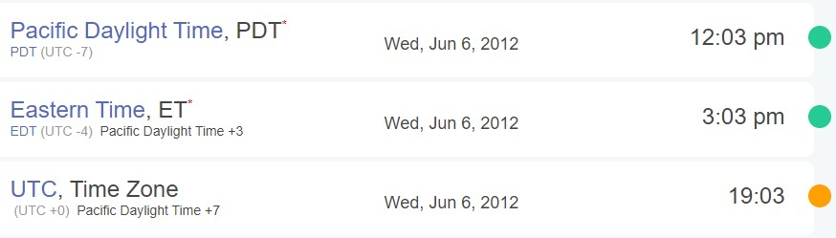

## EVIDENCE TO ESTABLISH PERSONAS

This section establishes aliases, phone numbers, emails addresses associated with each person, and relationships between each individual.

Tracy: (Alias name: Coral Blue)

|  |  |
| --- | --- |
| Phone Number: | (703) 340-9961 |
| Email: | tracysumtwelve@gmail.com |
| Work email: | tracy.sumtwelve@nationalgallerydc.org |
| Alias email: | coralbluetwo@hotmail.com |
| Relationship: | Ex-husband: Joe, and daughter Terry. |
| Status: | Accused |

The data collected is from Tracy’s phone, and the email associated with the Apple ID is ‘tracysumtwelve@gmail.com’ Also, her work email ‘tracy.sumtwelve@nationalgallerydc.org’ was setup on this phone, along with another email address under the alias name Coral Blue. Tracy is a supervisor at the NGDC. She is colluding with her brother, Pat (Perry), and his accomplice, King (Kart), to steal stamps at the NGDC. She is also getting some help from her colleague Carry (Cat) at NGDC to get some pictures on a tablet.

|  |  |
| --- | --- |
| Pat: (Alias name: Perry) |  |
| Phone Number: | (571) 308-3236 |
| Email: | patsumtwelve@gmail.com |
| Relationship:    Terry: | Brother (Accomplisher) |
| Phone Number: | (703) 829-6071 |
| Email: |  |
| Relationship:    Joe: | Daughter of Tracy and Joe |
| Phone Number: |  |
| Email: | joe.sum.twelve@gmail.com |
| Relationship: | Ex-husband of Tracy, and Father of Terry |

Joe is Tracy’s ex-husband and installed a keylogger program on Tracy’s laptop to monitor their daughter, Terry’s activity on the Internet. This tracking led Joe to find out about Tracy’s attempt to steal from NGDC and reported her to the police.

Carry: (Alias name: Cat)

Phone Number: (202) 725-2124

Email: carrysum2012@yahoo.com

Relationship: Acquaintance of Tracy

King: (Alias name: Kart)

Email: throne1966@hotmail.com

Relationship: Acquaintance of Pat

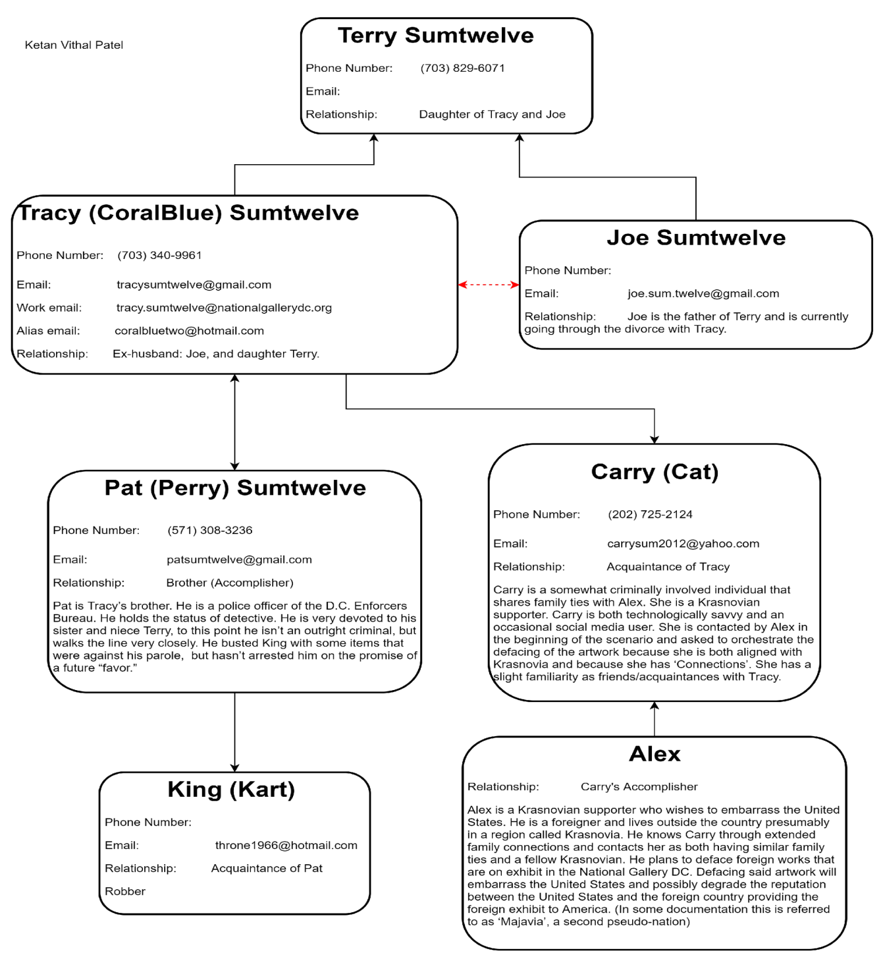

## EVIDENCE RELATING TO THE THEFT OF VALUABLE STAMPS

This sub-section provides details regarding the evidence found as it relates to the theft of valuable stamps.

Evidence has shown that Tracy, Pat, and King were corresponding with each other to steal valuable stamps from the NGDC. Tracy’s phone contained images of stamps that they were interested in stealing.

An email was sent from Pat to King telling him about the planned stamp heist at NGDC and is asking for his assistance, but instead is blackmailing him (see Appendix A, Artifact #2).

King sends an email with an attached document listing the tools he will need for this heist (see Appendix A, Artifact #4 and Appendix B, Artifact #4).

Pat forwards an email to Tracy, letting her know the tools that King will need (see Appendix A, Artifact #5 and Appendix B, Artifact #4).

In regards to the attachment stating the tools needed, Pat texts Tracy letting her know that her friend (actually Tracy) will need to change the attached file to a PDF format (see Appendix A, Artifact #106).

Tracy sends an email to herself with an attached ZIP file (see Appendix A, Artifact #3). This compressed file contained three pdf files which were memos about stamp insurance. The memos contained specific stamps and the amount each was insured for.

Appendix D contains the stamp images, of particular interest were the photographs of the following stamps mentioned in the insurance memos:

* Insurance memo, Stamp Insurance1.pdf (*see Appendix A, Artifact # 1*)
  1. Armed Forces Reserve (*see Appendix B, Artifact # 15*)

○ Stamp of Kazakstan2 (*see Appendix B, Artifact # 14*)

○ Brady & Co (*see Appendix B, Artifact # 16*)

* Insurance memo, Stamp Insurance2.pdf (*see Appendix A, Artifact # 2*)
  1. Woman’s Profile (*see Appendix B, Artifact # 26*)

○ Stamp of Kazakstan (*see Appendix B, Artifact # 10*)

○ 1929 Nepal (*see Appendix B, Artifact # 9*)

* Insurance memo, Stamp Insurance3.pdf (*see Appendix A, Artifact # 3*)
  1. Douglas MacArthur (*see Appendix B, Artifact # 13*)

○ Nederland (*see Appendix B, Artifact # 24*)

○ Mongolia (*see Appendix B, Artifact # 28*)

Tracy’s cell location (local) shows that she was near the vicinity or in the NGDC (*see Wi-Fi/GPS location information, Artifact # 8 & # 9*).

## EVIDENCE RELATING TO DEFACEMENT OF MUSEUM ART

This sub-section provides details regarding the evidence found as it relates to the Defacement of Museum art.

Evidence has shown that Tracy was communicating with Carry to assist with Carry’s “flash mob” by giving sensitive information about NGDC. Again, this was just a ruse to deface artwork at

NGDC.

Text messages detail the communication with Tracy and Carry about meeting up at Bubba’s grill (*see SMS Message Content, Artifacts # 7, # 8 & # 13, # 14*).

Another text message indicates another meetup between Tracy and Carry but this time, Tracy will bring Carry’s tablet in with her (*see SMS Message Content, Artifacts # 21 & # 22*).

In regards to the “flash mob”, Tracy asks to Carry how is that going via text message (*see SMS Message Content, Artifacts # 23*).

## PLOT TIMELINE

Email Content: /mobile/Library/Mail/Protected Indexed

SMS Content: /mobile/Library/SMS/sms.db

Call Data: /wireless/Library/CallHistory/call_history.db

Wifi & Cell Location Data: /root/Library/Caches/locationd/consolidated.db

|  |  |
| --- | --- |
| Plot Timeline | |
| Date | Information |
| Tuesday, June 19, 2012 | Pat sends Tracy information about a virtual machine. |
| Thursday, July 5, 2012 | Text messages between Tracy and Carry about meeting up at Bubba’s grill. |
| Friday, July 6, 2012 | Tracy meets up with Carry at Bubba’s grill. |
| Friday, July 6, 2012, through Tuesday, July 10, 2012 | Correspondence between Tracy, Pat, and King about the tools needed for the stamp heist. |
| Sunday, July 08, 2012 | Tracy photographs the stamps that they are interested in stealing. |
| Monday, July 09, 2012 | Tracy sends herself copies of memos regarding insurance for specific stamps. |
| Wednesday, July 11, 2012 | Tracy meets up with Carry again to take Carry’s tablet in with her. |
| Thursday, July 12, 2012 | Tracy asks to Carry about the status of the “flash mob”. |

## EMAIL CONTENT

|  |  |  |  |  |
| --- | --- | --- | --- | --- |
|  | Email Messages Timeline of NGDC | | | |
| Artifac t # | Timestamp | Header Information | Key Information | Evidence Location |
| 1 | Tuesday, Jun 19, 2012, 20:06:33 | F:  patsumtwelve@gmail.c om  T: tracysumtwelve@gmail.  com    Subject: Paris Speak and answer | Pat emails Tracy letting her know that he has accepted her proposal and asks her to email using her alias for further instructions. | Mailbox  Data  Structure |
| 2 | Tuesday, Jun 19, 2012, 20:26:47 | F:  perrypatsum@yahoo.c  om  T: tracysumtwelve@gmail.  com    Subject: Look me up sometime | Pat (Perry) emails Tracy to ask her to communicate using her alias. | Mailbox  Data  Structure |
| 3 | Tuesday, Jun 19, 2012, 21:38:59 | F:  perrypatsum@yahoo.c  om  T:  coralbluetwo@hotmail.  com    Subject: Crazydave by the VMs Attachment: Crazydave1.mp3 | Pat (Perry) emails Tracy (Coral) with instructions to install a Virtual Machine hidden in an audio file. | Mailbox  Data  Structure |
| 4 | Tuesday, Jun 19, 2012, 21:39:34 | F:  perrypatsum@yahoo.c  om  T:  coralbluetwo@hotmail.  com    Subject: Re: ??? | Pat (Perry) replies to Tracy (Coral) confirming that he was getting her emails. | Mailbox  Data  Structure |

|  |  |  |  |  |
| --- | --- | --- | --- | --- |
| 5 | Thursday, Jun 21, 2012, 17:43:15 | F:  perrypatsum@yahoo.c  om  T:  coralbluetwo@hotmail.  com    Subject: Re: Crazydave by the VMs | Pat (Perry) replies to Tracy (Coral) on an email thread about Virtual Machine installation saying that she should listen to some other songs as well.    In the email thread Tracy (Coral) confirms that the instructions sent earlier in the audio file helped her. | Mailbox  Data  Structure |
| 6 | Thursday, Jun 28, 2012, 19:31:33 | F:  perrypatsum@yahoo.c  om  T:  coralbluetwo@hotmail.  com    Subject: Whats going on | Pat (Perry) emails Tracy (Coral) asking her to henceforth communicate using the aliases and the Virtual Machine setup to keep them safer. He also indicates that they might have to get into riskier/illegal business since both of them were facing financial hardships.    He tells her that few of his workplace friends were good at these businesses and that he will inform her should something pop-up; in the meantime they should keep discussing some ideas for the same. | Mailbox  Data  Structure |

|  |  |  |  |  |
| --- | --- | --- | --- | --- |
| 7 | Friday, Jun 29, 2012, 14:21:56 | F:  perrypatsum@yahoo.c  om  T:  coralbluetwo@hotmail.  com    Subject: Re: Whats going on | This is an email thread between Pat (Perry) and Tracy (Coral) discussing ideas for making some money.    To Pat’s suggestion that they use the Virtual Machines and aliases to communicate and keep looking for ways to make money, Tracy replies that she will keep her eyes open for opportunities and insists that Pat try to get in on some business soon, since her kid didn’t want to change schools. She also indicates that she is paying attention to documents, especially insurance papers so that she could identify something of potential. Pat assures that he will make something happen although he is nervous because IA has been sniffing around. | Mailbox  Data  Structure |
| 8 | Friday, Jun 29, 2012, 14:31:36 | F:  perrypatsum@yahoo.c  om  T: tracysumtwelve@gmail.  com    Subject: hey sis | Pat (Perry) emails Tracy addressing her as ‘sister’ and enquires about Terry. Asks her to check in with Coral with whom he has been planning some things. He also suggests all of them going together for dinner as friends.    He asks Tracy to check in with Coral.    Possible misdirection attempted by referring to Coral as a third person in the narrative. | Mailbox  Data  Structure |

|  |  |  |  |  |
| --- | --- | --- | --- | --- |
| 9 | Friday, Jun 29, 2012, 15:21:35 | F:  perrypatsum@yahoo.c  om  T:  coralbluetwo@hotmail.  com    Subject: Re: Whats going on | Pat (Perry) replies to the email thread allaying Tracy’s (Coral) concern about IA sniffing around him. Tracy in her earlier email in the thread says that although nothing interesting has turned up yet she expects something soon. Pat in his email mentions that they can certainly get the job done if something like what they had earlier discussed pops up. | Mailbox  Data  Structure |
| 10 | Monday, Jul 02, 2012, 16:13:18 | F:  perrypatsum@yahoo.c om  T:  coralbluetwo@hotmail.  com    Subject: Re: Some good news | Email Thread: Some good news    Tracy (Coral) emails Pat (Perry) mentioning that some interesting foreign exhibit is going to happen and that from assessing the paperwork she feels that it would be a big deal.    Pat (Perry) replies back feeling hopeful about this being the opportunity they were looking for. | Mailbox  Data  Structure |
| 11 | Monday, Jul 02, 2012, 20:00:31 | F:  perrypatsum@yahoo.c  om  T:  coralbluetwo@hotmail.  com    Subject: Re: Some good news | Email thread: Some good  news    Following up on the earlier email about the exhibit, Tracy (Coral) mentions going through documents related to the exhibit from which she found that the exhibit is worth a lot of money but the shipping cost is very low comparatively.    Pat (Perry) emails back saying that such a thing may mean that the exhibit is something small which would be a very good thing for them. | Mailbox  Data  Structure |

|  |  |  |  |  |
| --- | --- | --- | --- | --- |
| 12 | Tuesday, Jul 03, 2012, 13:29:37 | F:  joe.sum.twelve@gmail.  com  T: tracysumtwelve@gmail.  com    Subject: Re: Regarding  Terry | Email Thread: Regarding  Terry    Tracy emails Joe asking whether he could help her with Terry’s tuition this year since it is becoming too expensive for her.    Joe replies back saying that he won’t be paying Terry’s tuition if she is not living with him. | Mailbox  Data  Structure |
| 13 | Tuesday, Jul 03, 2012, 14:53:04 | F:  perrypatsum@yahoo.c om  T  :coralbluetwo@hotmail.  com    Subject: Re: Some good news | Email Thread: Some good news    Tracy (Coral) emails Pat (Perry) saying that the exhibit is a rare and highly valuable stamp collection and that maybe this is their opportunity.    Pat (Perry) replies to Tracy (Coral) asking her to collect as much information as possible about the stamp exhibit and that in the meantime he would look into options for pulling off the heist. | Mailbox  Data  Structure |
| 14 | Thursday, Jul 05, 2012, 15:51:31 | F: carrysum2012@yahoo.  com  T: tracysumtwelve@gmail.  com    Subject: Long time no see… | Carry reaches out to Tracy asking her if they could meetup for lunch and suggests this Friday. She also mentions that through Facebook she realized that Tracy was having a hard time recently. | Mailbox  Data  Structure |

|  |  |  |  |  |
| --- | --- | --- | --- | --- |
| 15 | Friday, Jul 06, 2012, 15:27:51 | F:  patsumtwelve@gmail.c om  T: tracysumtwelve@gmail.  com    Subject: Re: Good  News | Email Thread: Good News    Tracy emailed Pat saying that she spoke with Coral and that Coral got some great news about her job and suggested that Pat catch up with Coral.    Pat replied back saying that he knows a guy called King. | Mailbox  Data  Structure |
| 16 | Friday, Jul 06, 2012, 15:49:31 | F:  patsumtwelve@gmail.c om  T:  throne1966@hotmail.c om  Cc:coralbluetwo@hotm  ail.com    Subject: can't pass up | Pat emails King with Tracy (Coral) in cc, saying that he has a lucrative proposition, a heist at the national gallery. He also threatens King to comply or else he would put King’s parole in jeopardy. | Mailbox  Data  Structure |
| 17 | Friday, Jul 06, 2012, 17:59:24 | F:  patsumtwelve@gmail.c om  T: tracysumtwelve@gmail.  com    Subject: Re: Good  News | Email Thread: Good News    Tracy suggests they (meaning King, Tracy and Pat) should hang out sometime.    Pat emails Tracy with account login information for: coralblue@hotmail.com Password: legalBee | Mailbox  Data  Structure |
| 18 | Monday, Jul 09, 2012, 18:18:47 | F: carrysum2012@yahoo. com  T: tracysumtwelve@gmail.  com    Subject: Re: Long time no see… | Email Thread: Long time no see... Tracy thanked Carry for the lunch.    Carry emails Tracy asking for help sneaking in a tablet for a flash mob event they had spoken earlier about. Carry suggests that Tracy would be compensated in some way for the help. | Mailbox  Data  Structure |

|  |  |  |  |  |
| --- | --- | --- | --- | --- |
| 19 | Tuesday, Jul 10, 2012, 13:48:40 | F: carrysum2012@yahoo. com  T: tracysumtwelve@gmail.  com    Subject: Re: Long time no see… | Email Thread: Long time no  see…    Tracy agrees to help Carry sneak in the tablet and asks when Carry would like to get in to take a look around the gallery.    Carry replies saying that this would be a big help and asks if she could come around 9 tomorrow. | Mailbox  Data  Structure |
| 20 | Wednesday, Jul  11, 2012, 17:06:19 | F: carrysum2012@yahoo. com  T: tracysumtwelve@gmail.  com    Subject: Re: Long time no see… | Email Thread: Long time no see    Tracy confirms the meet at 9 tomorrow.    Carry wants Tracy to pass her information regarding shift changes of security. She suggests that Tracy would be well compensated for the information.    Tracy confirms that she will give the security shift information Carry requested in exchange for money but asks Carrie to be careful with it.    Carry replies asking Tracy not to worry and says “It will be a gun”. | Mailbox  Data  Structure |
| 21 | Wednesday, Jul  11, 2012, 19:28:53 | F: "Google+" <noreply- 5dd47ca1@plus.google  .com>  T: tracysumtwelve@gmail.  com    Subject: Carry Carsumtwotwelve added you on Google+ | Email Thread: Long time no see    Previous email from the thread from Carry asking for the security shift details from Tracy. | Mailbox  Data  Structure |
| 22 | Wednesday, Jul  11, 2012, 23:22:03 | F: "Carry  Carsumtwotwelve  (Google+)" <replyto- 748d3d22@plus.google  .com>  T: tracysumtwelve@gmail.  com    Subject: Carry Carsumtwotwelve is sharing with you on  Google+ | Notification from Google+ informing Tracy that Carry had shared an album. | Mailbox  Data  Structure |
| 23 | Thursday, Jul 12, 2012, 16:12:07 | F: "Carry  Carsumtwotwelve  (Google+)" <replyto- 748d3d22@plus.google  .com>  T: tracysumtwelve@gmail.  com    Subject: Carry Carsumtwotwelve is sharing with you on  Google+ | Notification from Google+ informing Tracy that Carry had shared an album. | Mailbox  Data  Structure |
| 24 | Thursday, Jul 12, 2012, 18:03:51 | F: carrysum2012@yahoo. com  T: tracysumtwelve@gmail.  com    Subject: Re: Long time no see… | Email Thread: Long time no  see…    Tracy emailed Carry asking her what she meant by “It will be a gun”.    Carry replies saying that it was a typographical error and she meant “It will be fun”. | Mailbox  Data  Structure |

## SMS MESSAGE CONTENT

|  |  |  |  |
| --- | --- | --- | --- |
|  | SMS Messages Timeline of NGDC | | |
| Artifact # | Timestamp | Header  Information | Key Information |
| 1 | Tuesday, Jun 12, 2012, 21:25:04 | F: Pat T: Tracy | Pat asks Tracy about her plans for the weekend |
| 2 | Wednesday, Jun 13, 2012, 17:30:28 | F: Terry T: Tracy | I'm going out with dad after school for pizza! Thought  I'd let you know if you planned to cook. ↩ T |
| 3 | Wednesday, Jun 13, 2012, 18:30:38 | F: Tracy T: Pat | Tracy replies to Pats’ message saying that she has no big plans and enquires about his plans. |
| 4 | Wednesday, Jun 13, 2012, 18:33:46 | F: Tracy T: Terry | Ok, sounds good. |
| 5 | Tuesday, Jul 03, 2012, 13:41:51 | F: Tracy T: Terry | Tracy messages Terry asking about her opinion on  switching schools since they can’t Prufrock anymore. |
| 6 | Tuesday, Jul 03, 2012, 14:04:32 | F: Terry T: Tracy | Terry replies back saying that she doesn’t want to switch schools and would rather stay with her dad and continue at Prufrock |
| 7 | Thursday, Jul 05, 2012, 18:18:23 | F: Carry T: Tracy | Carry sets up the time and location as 1 pm at  Bubba’s grill for meeting with Tracy |
| 8 | Thursday, Jul 05, 2012, 18:20:26 | F: Tracy T: Carry | Tracy confirms the meeting time and location |
| 9 | Friday, Jul 06, 2012, 15:02:19 | F: Tracy T: Pat | Tracy asks Pat to give her a call |
| 10 | Friday, Jul 06, 2012, 15:08:37 | F: Pat T: Tracy | Pat says he is busy and suggests calling later |
| 11 | Friday, Jul 06, 2012, 15:11:54 | F: Tracy T: Pat | Tracy says it’s important and insists that pat call her soon |
| 12 | Friday, Jul 06, 2012, 15:13:31 | F: Pat T: Tracy | Pat says he will call in 5 min |
| 13 | Friday, Jul 06, 2012, 16:27:16 | F: Carry T: Tracy | Carry messages saying she has a table inside |
| 14 | Friday, Jul 06, 2012, 16:27:50 | F: Tracy T: Carry | Tracy replies back saying that she will be there. |
| 15 | Tuesday, Jul 10, 2012, 15:26:19 | F: Pat T: Tracy | Pat messages Tracy telling her about the email and informing her that the attachment needs to be changed to pdf. He asks Tracy to tell this information to Coral. |
| 16 | Tuesday, Jul 10, 2012, 15:58:04 | F: Tracy T: Pat | Tracy acknowledges the email and message. |
| 17 | Tuesday, Jul 10, 2012, 16:37:09 | F: Tracy  T: Pat  *Failed | Tracy tried to share the following location with Pat over MMS message but it failed.  Location: 2600-2700 24th Rd S, Arlington, VA 22206 |
| 18 | Tuesday, Jul 10, 2012, 17:18:38 | F: Tracy T: Terry | Tracy messages Terry for Lunch |
| 19 | Tuesday, Jul 10, 2012, 18:19:24 | F: Tracy T: Terry | Tracy messages Terry that she is back at work. |
| 20 | Tuesday, Jul 10, 2012, 18:58:24 | F: Terry T: Tracy | Terry messages Tracy saying she is busy and suggests meeting up over the weekend if her dad isn’t busy. |
| 21 | Wednesday, Jul 11, 2012,  12:41:45 | F: Carry T: Tracy | Carry messages, Tracy, informing that she is almost there (NGDC) |
| 22 | Wednesday, Jul 11, 2012, 12:49:08 | F: Tracy T: Carry | Tracy replies to Carry asking her to meet out front. She says that she will take the tablet in. |
| 23 | Thursday, Jul 12, 2012, 17:06:45 | F: Tracy T: Carry | Tracy messages Carry asking her about the flash mob |

## WI-FI/GPS LOCATION INFORMATION

|  |  |  |  |  |
| --- | --- | --- | --- | --- |
| WI-FI/GPS Location Information | | | | |
| Artifact # | Timestamp | Header  Information | Body | Map Screenshot |
| 1 | Wednesday,  June 13,  2012,  7:01:21 PM  (UTC) | Cell Location:  38°52'39.6"N  77°06'55.7"W | Location: Virginia  Tech Research  Center – Arlington  (900 N Glebe Rd,  Arlington, VA  22203, USA) |  |
| 2 | Sunday,  June 13,  1915 7:01:22  PM (UTC) | Wifi Location:  38°52'50.0"  N  77°06'55.9"  W | Location: Virginia  Tech Research  Center – Arlington  (900 N Glebe Rd,  Arlington, VA  22203, USA) |
| 3 | Monday, July  2, 2012,  4:19:23 PM | Cell Location: 38°52'51.3"N  77°07'01.6"W | Location:  4600 Fairfax Dr,  Arlington, VA  22203, USA |  |
| 4 | Monday, July  2, 2012,  4:19:24 PM | Wifi Location:  38°52'47.7"  N  77°06'52.6"  W | Location:  800 N Glebe Rd,  Arlington, VA  22203, United  States |
| 5 | Tuesday,  July 3, 2012,  1:42:42 PM | Wifi Location:  38°52'50.3"  N  77°06'56.1"  W | Location:  900 N Glebe Rd,  Arlington, VA  22203, USA |  |
| 6 | Thursday, | Cell Location: | Location: |  |

|  |  |  |  |  |
| --- | --- | --- | --- | --- |
|  | July 5, 2012, 4:32:46 PM | 38°52'46.2"  N  77°06'52.6"  W | Arlington, VA  22203, United  States |  |
| 7 | Thursday,  July 5, 2012,  4:32:47 PM | Wifi Location:  38°52'49.9"  N  77°06'52.0"  W | Location:  801 N Glebe Rd,  Arlington, VA  22203, USA |
| 8 | Sunday, July  8, 2012,  12:33:36 PM  EDT | Cell Location  38°53'30.0"N  77°01'24.6"W | National Gallery of Art,  Washington, DC  20408, United  States |  |

|  |  |  |  |  |
| --- | --- | --- | --- | --- |
| 9 | Sunday, July  8, 2012,  12:41:41 PM  EDT | Cell Location  38°53'27.0"N  77°01'19.8"W | Northwest  Washington,  Washington, DC  20408, USA |  |
| 10 | Tuesday,  July 10,  2012,  4:31:10 PM | Cell Location:  38°51'05.1"  N  77°04'41.7"  W | Location:  1700 Army Navy  Dr, Arlington, VA  22202, USA |  |
| 11 | Tuesday,  July 10,  2012,  4:31:12 PM | Wifi Location;  38°50'54.0"  N  77°04'55.9"  W | Location:  2693 24th Rd S,  Arlington, VA  22206, USA |  |
| 12 | Tuesday,  July 10,  2012,  4:45:00 PM | Cell Location:  38°49'37.4"  N  77°05'10.0"  W | Location:  1737 W  Braddock Pl,  Alexandria, VA  22302, USA |  |
| 13 | Tuesday,  July 10,  2012,  4:45:01 PM | Wifi Location:  38°49'39.5"  N  77°05'17.0"  W | Location:  4104 36th St S,  Arlington, VA  22206, USA |  |
| 14 | Tuesday,  July 10,  2012,  4:46:29 PM | Wifi Location:  38°49'44.7"  N  77°05'05.1"  W | Location:  1701 Centre  Plaza,  Alexandria, VA  22302, United  States |  |

## CONCLUSION

Evidence found on Tracy’s iPhone indicated the following:

From the email correspondence, text messages, photo images, and other miscellaneous information, the evidence has shown that Terry was colluding with Pat and King to steal valuable stamps from the NGDC. Another discovery from this investigation was Terry’s willingness to give sensitive information to help out Carry’s “flash mob”. This information was gathered to wanting to damage artwork at NGDC.

The email correspondence has revealed that both Tracy and Pat were using alias names. Tracy’s alias name was Coral while Pat’s was Perry.

It also has come to light that Terry was having financial issues with paying for her daughter, Terry’s tuition at Prufrock from her text messages and a note to herself on her phone.

The evidence of the attachment file stating the tools needed for this heist, stamp insurance memos, and stamp photo images revealed the details and planning that went into this heist of stealing stamps at NGDC. The discovery to deface artwork at NGDC was a consequence of finding out about the heist.

|  |  |  |  |  |
| --- | --- | --- | --- | --- |
|  | Correspondence Attachments | | |  |
| Artifact # | Timestamp | Header Information | Attachment Location | Attachment Screenshot |
| 1 | Received: July 09, 2012, 2:47:58 PM | From: Tracy Sumtwelve (tracysumtwelve@gmail.com) To:  coralbluetwo@hotmail.com  Subject: Things  Attachment: documents.zip | File:  /Attachments/61/3/docs.zip/docs  /Stamp Insurance 1.pdf | See Page 11 |
| 2 | Received: July 09, 2012, 2:47:58 PM | From: Tracy Sumtwelve (tracysumtwelve@gmail.com) To:  coralbluetwo@hotmail.com  Subject: Things  Attachment: documents.zip | File:  /Attachments/61/3/docs.zip/docs  /Stamp Insurance 2.pdf | See Page 12 |
| 3 | Received: July 09, 2012, 2:47:58 PM | From: Tracy Sumtwelve (tracysumtwelve@gmail.com) To:  coralbluetwo@hotmail.com  Subject: Things  Attachment: documents.zip | File:  /Attachments/61/3/docs.zip/docs  /Stamp Insurance 3.pdf | See Page 13 |
| 4 | Received: July 10,  2012, 11:19:00  AM | From: King kthings  (throne1966@hotmail.com)  To: patsumtwelve@gmail.com  Subject: Re: can’t pass up  Attachment: needs.txt | File: /Attachments/60/2/needs.txt | See Page 14 |

## APPENDIX A: CORRESPONDENCE ATTACHMENTS

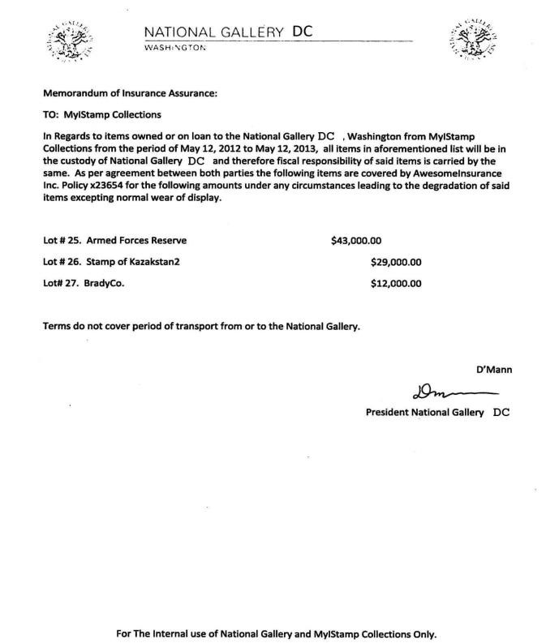

|  |  |  |  |  |
| --- | --- | --- | --- | --- |
|  |  | Phone Images found in the Device | | |
| Artifact # | Timestamp | Header Information | Body | Image Screenshot |
| 1 | July 8, 2012, 12:33:36 PM  EDT    38.89166666  77.0235    78.04526748  971193 | File:  /mobile/Media/DCIM/100  APPLE/IMG_0042    Size: 889146    Artifact ID: -  9333372036854775807    Internal ID: 43377 | Outside of  NGDC of  Arts  Sculpture |  |
| 2 | July 8, 2012, 12:34:31 PM  EDT    38.89166666  77.0235    78.04526748  971193 | File:  /mobile/Media/DCIM/100  APPLE/IMG_0043    Size: 704549    Artifact ID: -  9223372036854775806    Internal ID: 43379 | Outside of  National  Gallery of  Arts  Sculpture |  |

## APPENDIX B: PHOTOS

|  |  |  |  |  |
| --- | --- | --- | --- | --- |
| 3 | July 8, 2012, 12:34:50 PM  EDT    38.89166666  6666666 77.0235    78.04526748  971193 | File:  /mobile/Media/DCIM/100  APPLE/IMG_0044    Size: 588093    Artifact ID: -  9223372036854775805    Internal ID: 43381 | Outside of  National  Gallery of  Arts  Sculpture |  |
| 4 | July 8, 2012, 12:35:50 PM  EDT    38.89133333  3333336 77.02283333  333334    52.04565217  391304 | File:  /mobile/Media/DCIM/100  APPLE/IMG_0045    Size: 809006    Artifact ID: -  9223372036854775804    Internal ID: 43383 | Outside of  National  Gallery of  Arts  Sculpture |  |

|  |  |  |  |  |
| --- | --- | --- | --- | --- |
| 5 | July 8, 2012, 12:36:30 PM  EDT    38.89133333  3333336 77.0225    52.04580690  627202 | File:  /mobile/Media/DCIM/100  APPLE/IMG_0046    Size: 936833    Artifact ID: -  9223372036854775803    Internal ID: 43385 | Outside of  National  Gallery of  Arts  Sculpture |  |
| 6 | July 8, 2012, 12:37:16 PM  EDT    38.89083333  333333 77.02216666  666666    54.04616182  572614 | File:  /mobile/Media/DCIM/100  APPLE/IMG_0047    Size: 651290    Artifact ID: -  9223372036854775802    Internal ID: 43387 | Outside of  National  Gallery of  Arts  Sculpture |  |

|  |  |  |  |  |
| --- | --- | --- | --- | --- |
| 7 | July 8, 2012, 12:37:37 PM  EDT    38.89083333  333333 77.02216666  666666    54.04618473  895582 | File:  /mobile/Media/DCIM/100  APPLE/IMG_0048    Size: 559050    Artifact ID: -  9223372036854775801    Internal ID: 43389 | Outside of  National  Gallery of  Arts  Sculpture |  |
| 8 | July 8, 2012, 12:41:41 PM  EDT    38.89166666  6666666 77.0235    78.04526748  971193 | File:  /mobile/Media/DCIM/100  APPLE/IMG_0049    Size: 533136    Artifact ID: -  9223372036854775800    Internal ID: 43391 | Stamps |  |

|  |  |  |  |  |
| --- | --- | --- | --- | --- |
| 12 | July 8, 2012, 12:44:13 PM | File:  /mobile/Media/DCIM/100  APPLE/IMG_0053    Size: 596847    MD5 Artifact ID: -  9223372036854775796    Internal ID: 43399 | Misc. |  |
| 13 | July 8, 2012, 12:49:25 PM  EDT    38.89766666  6666666 77.01966666  666667 | File:  /mobile/Media/DCIM/100  APPLE/IMG_0054    Size: 718217    Artifact ID: -  9223372036854775795    Internal ID: 43401 | 1971  General  Douglas  MacArthur  Plate Block  Of 4 6c  Postage  Stamps |  |